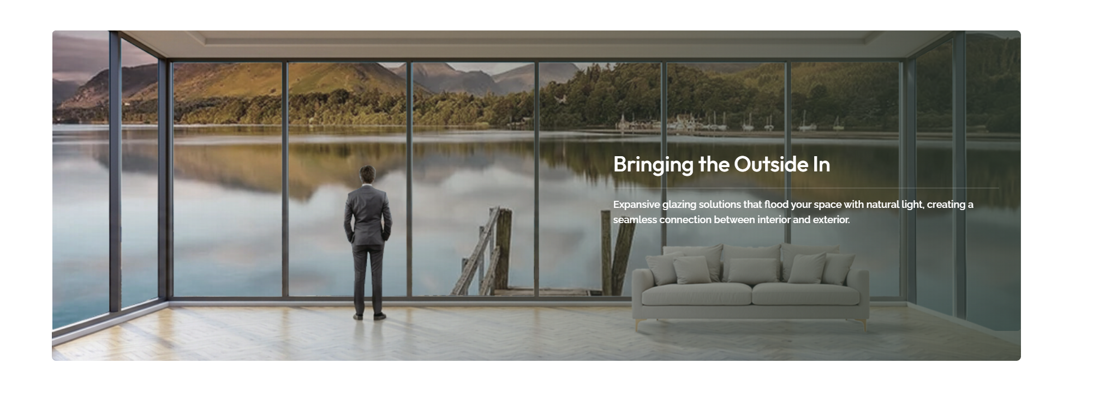

Do not change content, only change image behind the human frame.

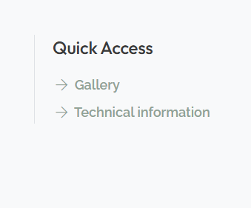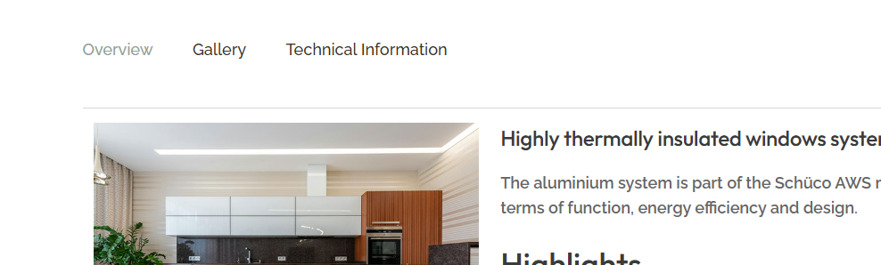

Add Brochure Download link & Tab at both places respectively.

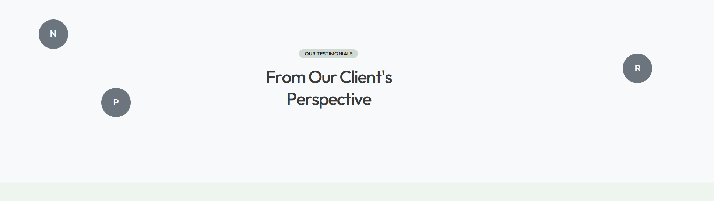

Force admin not to add more than 6 testimonials.

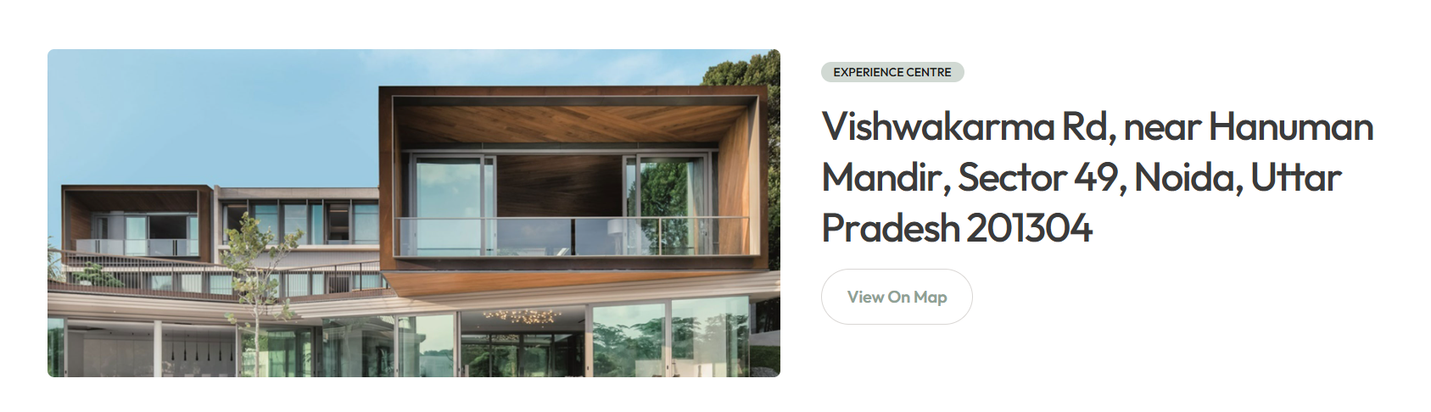

Under settings -> put address and image dynamic and input for cta link

